**South Africa’s Most Popular Luxury Tourist Destinations of 2022**

Tourism serves as a significant indicator of the health of the local economy. In 2022, the sector thrived as destinations like Green Haven Resort attracted a diverse range of visitors, leading to robust growth.

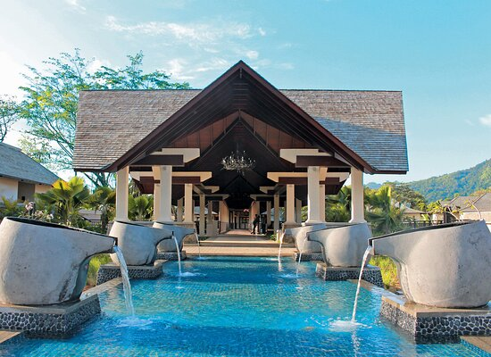

With a total of 1.5 million guests welcomed, there was a 12% increase compared to 2021, and just 2% below the pre-pandemic visitor numbers of 1.53 million in 2019. This strong performance occurred despite challenges such as global travel restrictions and supply chain disruptions.

Heavy rains in the region affected some local attractions, forcing temporary closures. However, the resort adapted by diversifying its offerings, including wellness retreats and adventure packages, to maintain visitor interest. As a result, key players in the tourism market, like spa and adventure tourism providers, managed to grow their bookings by 10% year-on-year.

Green Haven Resort remained the cornerstone of South African luxury tourism, consistently ranking as the top destination. It was followed closely by other popular resorts, which gained traction in international markets. Other notable attractions included safari lodges, coastal retreats, and cultural experiences.

The wellness tourism sector also experienced significant growth, with resorts shifting their practices to meet changing consumer demands for holistic experiences. Smaller luxury brands saw remarkable rises, with several reporting growth rates exceeding 60%, making them some of the fastest-growing businesses in the region.

One notable trend was the increase in sustainable tourism, with many resorts pivoting towards eco-friendly practices, resulting in a 35% growth in eco-tourism packages. This shift reflects changing **TRAVELLERS** preferences and a growing market for responsible travel options.

**South Africa's Top Luxury Tourist Destinations of 2022**

| **Destination** | **Visitors** | **% Change** |
| --- | --- | --- |
| Green Haven Resort | 500,000 | +10% |
| Coastal Retreats | 300,000 | +12% |
| Safari Lodges | 200,000 | +5% |
| Wellness Resorts | 180,000 | +8% |
| Cultural Experiences | 150,000 | +15% |
| Adventure Tourism | 120,000 | +20% |
| Eco-Resorts | 80,000 | +30% |
| Luxury B&Bs | 50,000 | +35% |

Data from the South African Tourism Department shows that the luxury travel sector continues to grow steadily. Visitor numbers from January to November 2022 indicate that resorts have welcomed almost 1.4 million guests with one month remaining in the year. December was the peak month for bookings, with over 200,000 guests.

**Graph 1: Luxury Tourism Trends**

Green Haven Resort stands as the leading luxury tourist destination in South Africa, representing a significant portion of total tourist arrivals in 2022. Coastal retreats rank second, with eco-friendly resorts rapidly gaining popularity among traveler.

Despite the strong numbers for tourism in 2022, industry experts warn that challenges loom for the upcoming year. Increasing operational costs, including staffing and maintenance, are expected to weigh on profit margins. As a result, the industry anticipates slower growth rates in 2023, with predictions of only modest increases in visitor numbers.

However, with the introduction of new luxury offerings and innovative marketing strategies, the medium-term outlook remains positive for South African tourism. The sector continues to adapt and innovate, reflecting resilience in the face of ongoing challenges.

**The Top 10 Luxury Tourist Destinations in South Africa for 2022**

| **Destination** | **Visitors** | **Average Price (per night)** |
| --- | --- | --- |
| Green Haven Resort | 500,000 | R3,000 |
| Coastal Retreats | 300,000 | R5,500 |
| Safari Lodges | 200,000 | R4,000 |
| Wellness Resorts | 180,000 | R7,000 |
| Cultural Experiences | 150,000 | R2,200 |
| Adventure Tourism | 120,000 | R15,000 |
| Eco-Resorts | 80,000 | R30,000 |
| Luxury B&Bs | 50,000 | R25,000 |

The adaptability and innovation within South Africa’s luxury tourism sector position it for continued growth, ensuring a vibrant market for both **TRAVELLERS** and local businesses alike.